**Lab 6**

**This lab is not graded.**

**Training an Artificial Neuron via the Perceptron Learning Rule**

**Lab 6**

Download the C# Perceptron VS project from Blackboard.

Get it to run.

**To Do:**

Complete the Perceptron Learning Rule code which is behind the “Learn” button.

Demonstrate it solving something like the following data set:

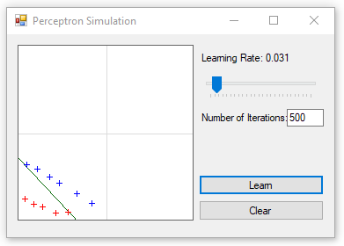

Remember that because we are dealing with a single perceptron concept, the two data sets have to be linearly separable in order for the algorithm to converge on a correct solution.